**Future Credit - User Manual**

|  |  |  |  |
| --- | --- | --- | --- |
| Document Number. | UM | Document Name | User Manual |
| Writer | Li Xiaodong | Date | 2017-9-13 |

1. About this manual

This manual is a user manual of the future credit webpage, which details the software functions and the user guide of future credit.

2. Software overview

The software is divided into server side and webpage. The website is based on the social reality that college students' borrowing activities are active but lacking credit, it is a third party bridge function for college students to perfect personal credit, helps bank obtain credit for college students and generates borrowing activities. Website is mainly responsible for providing perfect credit and viewing the user interface of loans and repayment, the server is responsible for data acquisition, storage and analysis.

3. Using wizard

3.1 home pages

Home as shown:

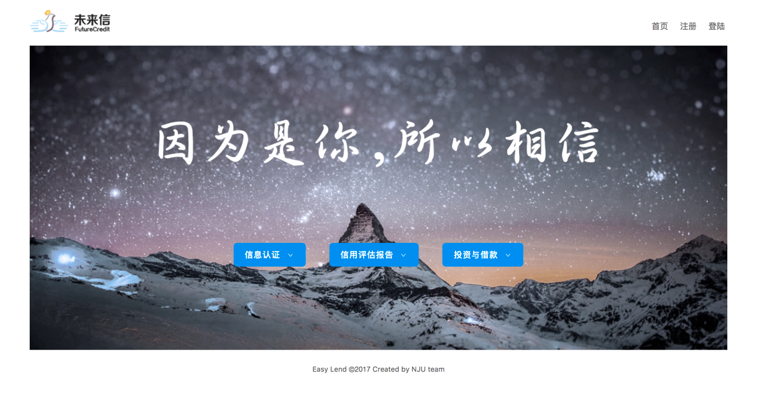

Home interface set up registration and login buttons, the user can click to pop up the registration and login interface. At the same time, home page has interface corresponding of directly into the information authentication, credit assessment report and investment.

3.2 Login Registration

3.2.1 Login pop-up interface:

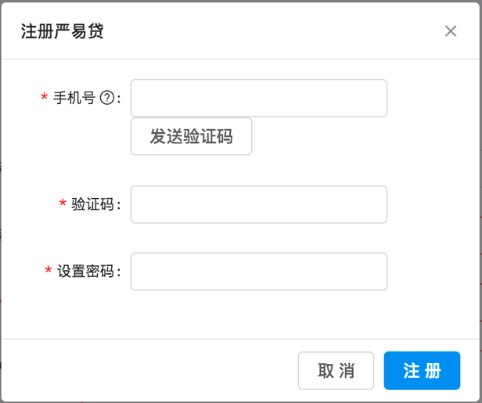

The user enters the personal mobile phone number, points the button of sending the verification code to obtain the verification code, sets the personal login password, clicks to register.

3.2.2 Registration pop-up interface:

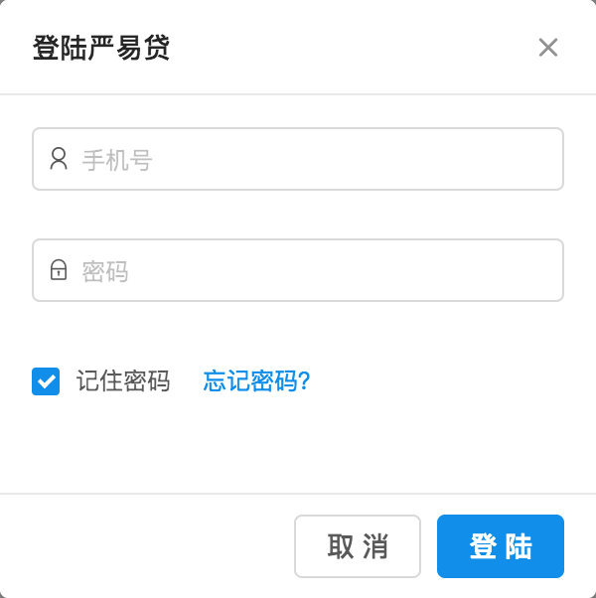

The user logs in with entering the phone number and password when they register, can set remember the password and if forgot the password, he can edit the forgotten password to get back.

3.3 internal home pages (basic information entry interface)

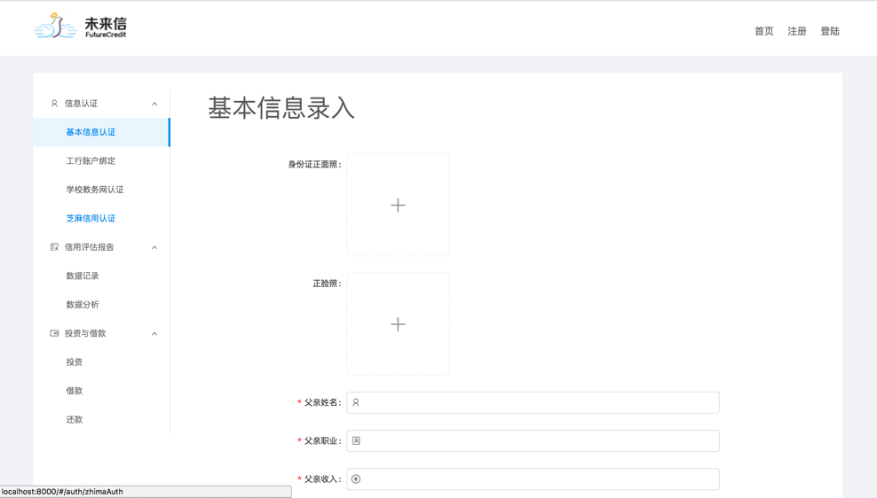

It will display the entering of the basic interface when users enter future credit first time, the left part is the drawer bar, users can click on the link to the corresponding interface, and the upper right corner is the button to return the home page, register and login. The entering of basic information need to take the positive identity card photo, face photo, clicks the pop-up file selection box, select photo. Parents name, occupation, income need be filled in truth.

3.3.1 Sidebar

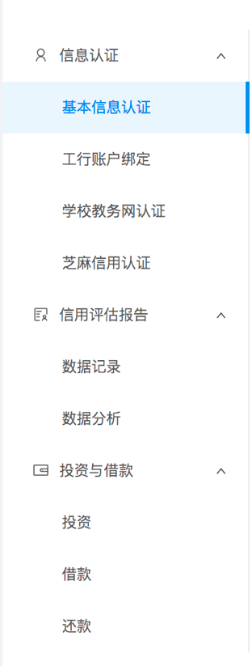

The sidebar includes basic information authentication, ICBC account binding, school educational network certification, sesame credit certification, data record, data analysis, investment, loan and repayment, click to enter the corresponding function page.

3.4 ICBC bank card binding

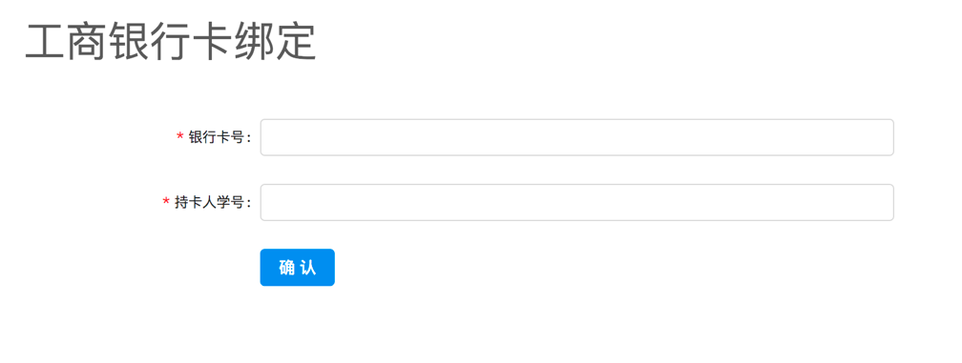

The user can bind the bank card by entering the bank card number and the cardholder number, clicks OK to initiate the binding.

3.5 Educational network certification

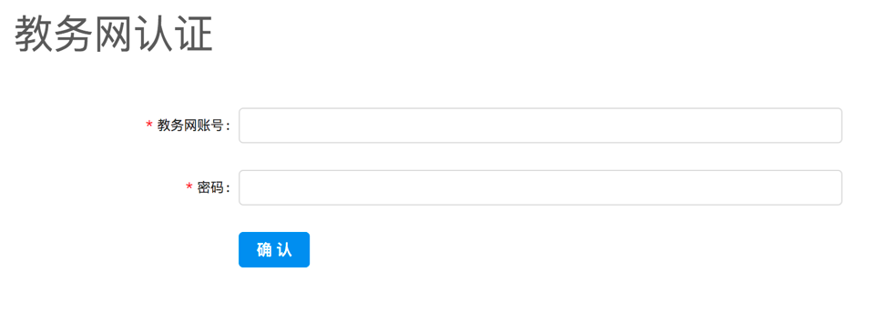

The user enters the educational network account number and password number to bind the bank card, click OK to initiate the authentication

3.6 Sesame credit certification

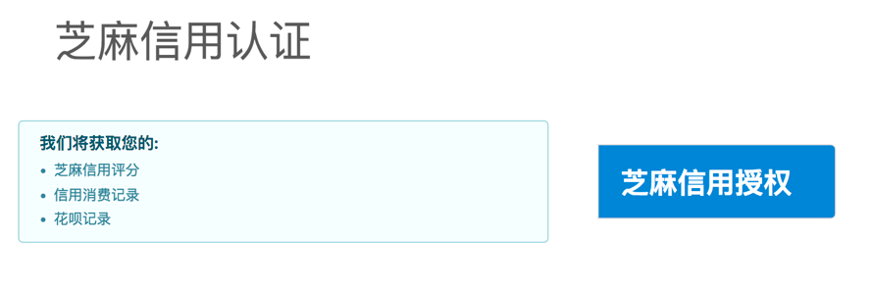

Users click on sesame credit authorization, the system prompts the completion of the situation.

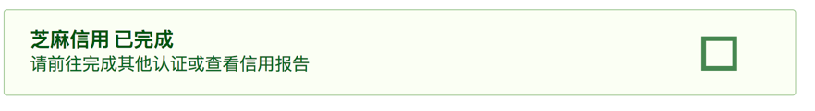

3.7 Data records

The data logging interface records all the information that the user has authenticated and the credit related information obtained from the third-party platform. The interface is as follows:

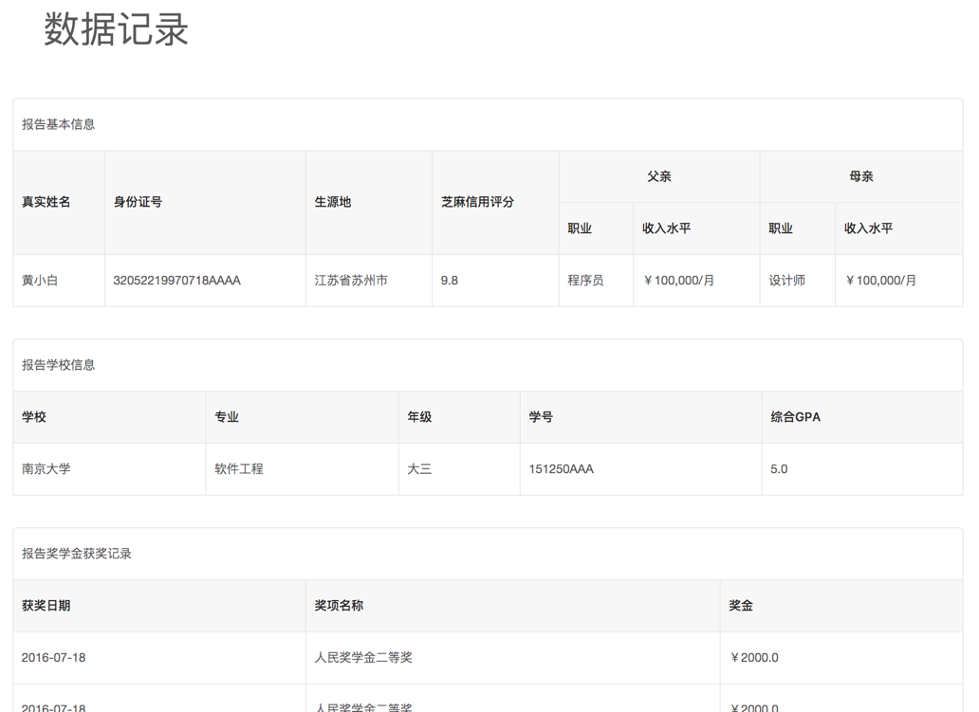

Specific entries include:

Basic Information

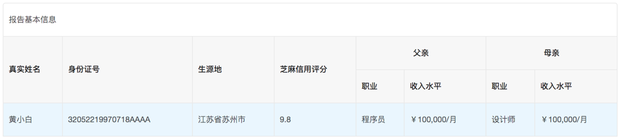

School information

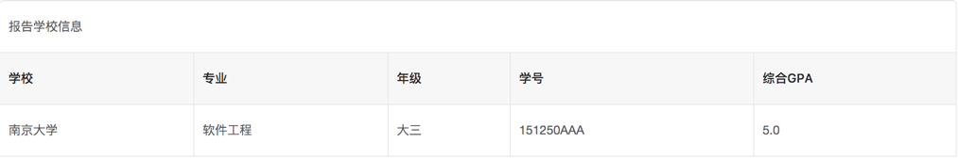

Scholarships record

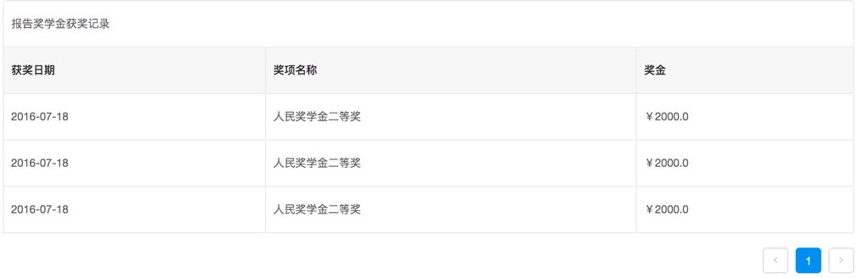

Volunteer record

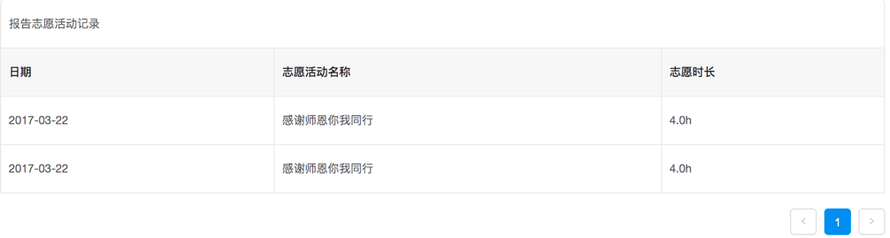

Bank card consumption record

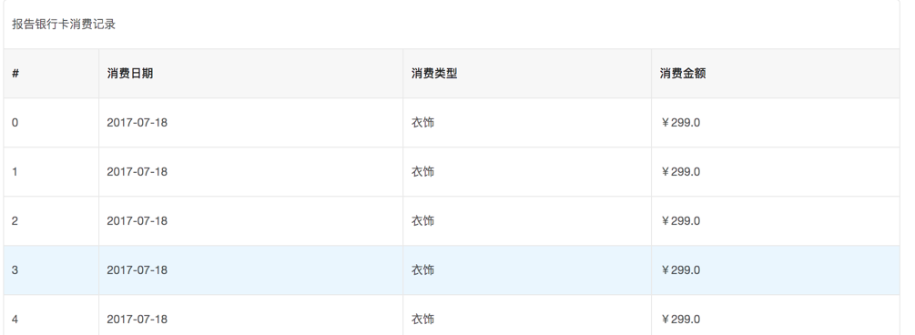

3.8 Data analysis

Data analysis function is based on the user's credit information to do data visualization display, the interface is as follows:

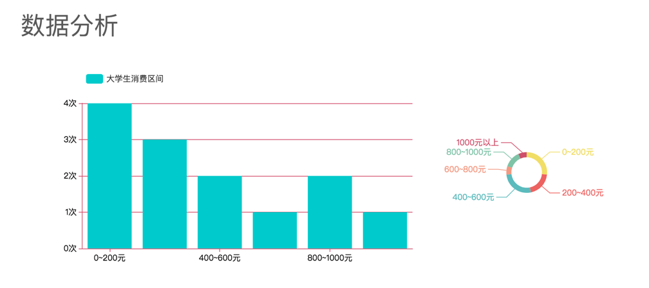

3.9 Investment

The interface is as follows:

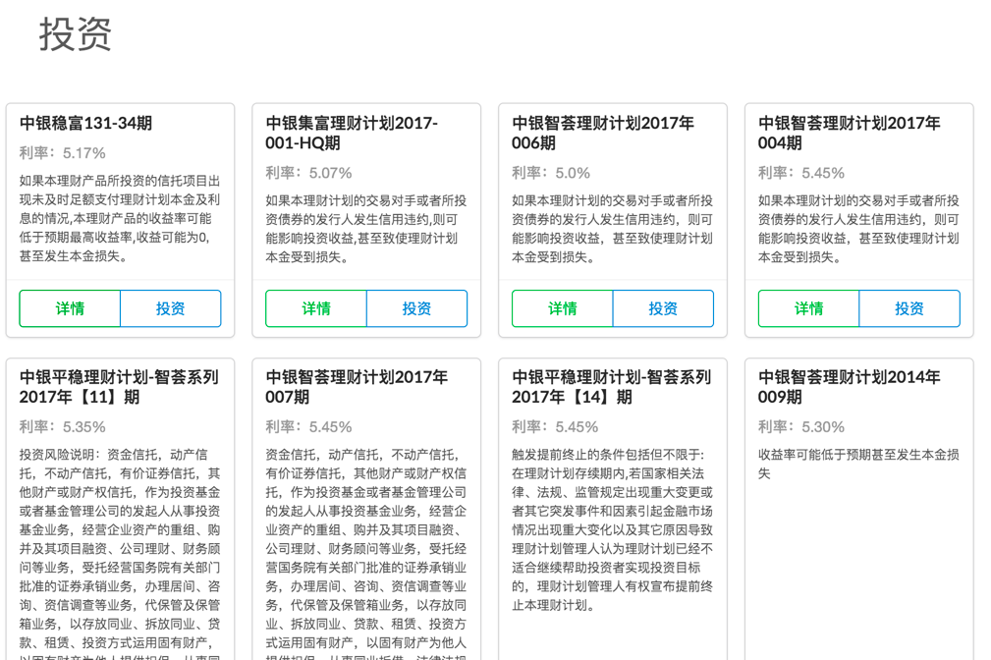

For the subject of investment that system provide, the user can view the details and invest.

3.10 borrowing

The interface is as follows:

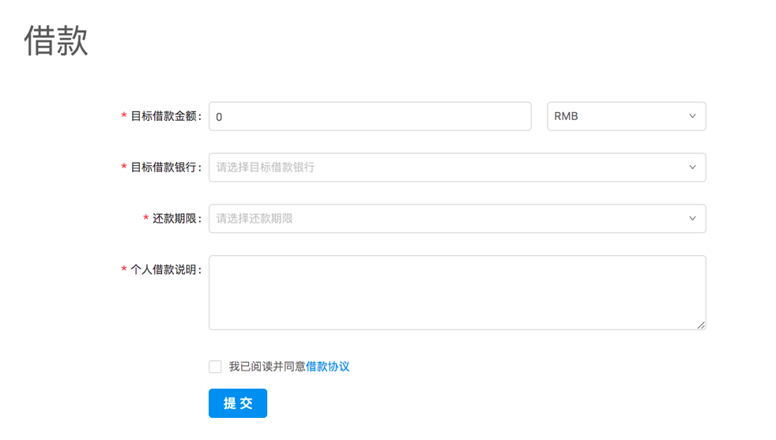

Borrowing process: Precondition is user has logged in and the basic information has been certified. User fills the borrowing amount, select unit, target borrowing bank, repayment term, personal borrowing instructions, then agrees with the loan agreement, submits and waits for system review.

3.11 Repayment

The interface is as follows:

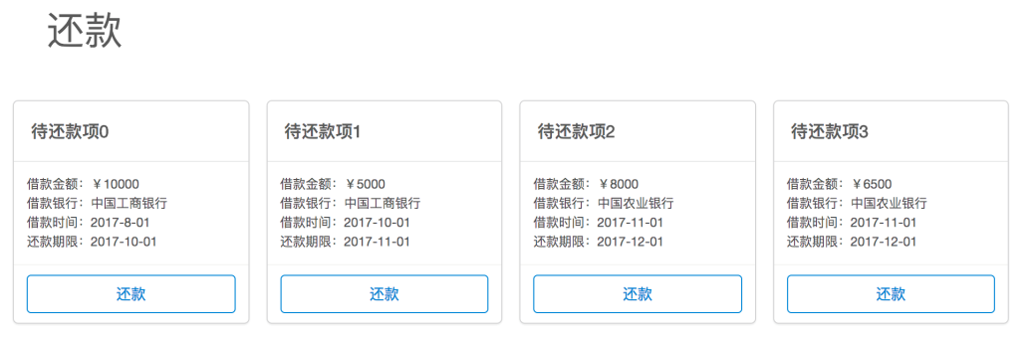

The system shows the subject that need to repay, the user clicks the repay button to enter the repayment channel.